**ABSTRACT**

**HEALTH MONITORING SYSTEM**

Currently, the COVID 19 pandemic is one of the global issues faced by health organizations. As of February 2022, the total number of people worldwide confirmed to have been infected with COVID is more than 399 million people. As the increasing technology the ongoing COVID 19 pandemic, IOT (Internet of Things) based health monitoring system that is a real time health monitoring systems are potentially immensely beneficial for COVID-19 patients. This study presents an IOT based system that is a real time health monitoring system utilizing measured values of body temperature, pulse rate, oxygen saturation of the patient, ECG reading. Which are mostly measurements required for critical care. It is an Arduino based system which is easy to code and as well as an GSM module for connecting and sending messages to the doctor as also the patients relatives or guardians. This helps in preventing the spread of the COVID-19 in turn helping world fight against spread of CORONA VIRUS.

**BLOCK DIAGRAM**

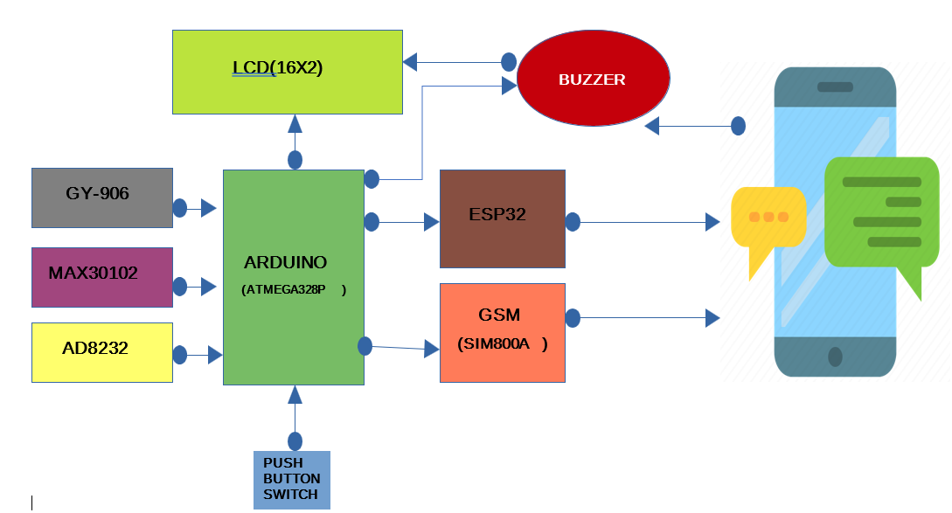

**TEAM MEMBERS**

|  |  |  |
| --- | --- | --- |
| **S.No** | **PIN** | **NAME** |
| 01. | 19253-EC-224 | U. SAI KUMAR |
| 02. | 19253-EC-228 | N. KARTHIK |
| 03. | 19253-EC-238 | M. SUNNY BABU |
| 04. | 19253-EC-243 | T. RAJEEV |
| 05. | 19253-EC-253 | K. PALLAVI |